**CST 235 Network and System Administration**

**Practice Your Knowledge on VLAN**

Name: ______Ben Walker_________________________________________

Date: _______06-21-18___________________________________________

**1. Description**

Switching has become the standard for most company internal network infrastructure as each port maintains its own collision domain, and with the advent of VLANs further allow the engineer to segment the network into multiple, smaller broadcast domains. As a Cisco engineer, as well as in the Cisco CCNA exam, you will need to know how to configure VLANs on Cisco switches as well as verify the option.

**2. Lab Procedures**

**2.1 Topology**

Step 1: Creating the topology as following figure, where six PCs connected to the same switch

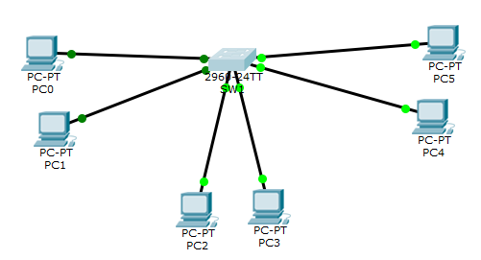

* PC0 interface FastEthernet 0 connect to swtich interface Fa0/1,
* PC1 interface FastEthernet 0 connect to swtich interface Fa0/2
* PC2 interface FastEthernet 0 connect to swtich interface Fa0/3
* PC3 interface FastEthernet 0 connect to swtich interface Fa0/4
* PC4 interface FastEthernet 0 connect to swtich interface Fa0/5,
* PC5 interface FastEthernet 0 connect to swtich interface Fa0/6

**2.2 General Settings**

Step 2: Configure the hostname and display name on Switch0 to be SW1.

C:\Users\75LCUI\AppData\Local\Temp\1493406128(1).png

**Show your topology with screenshot.**

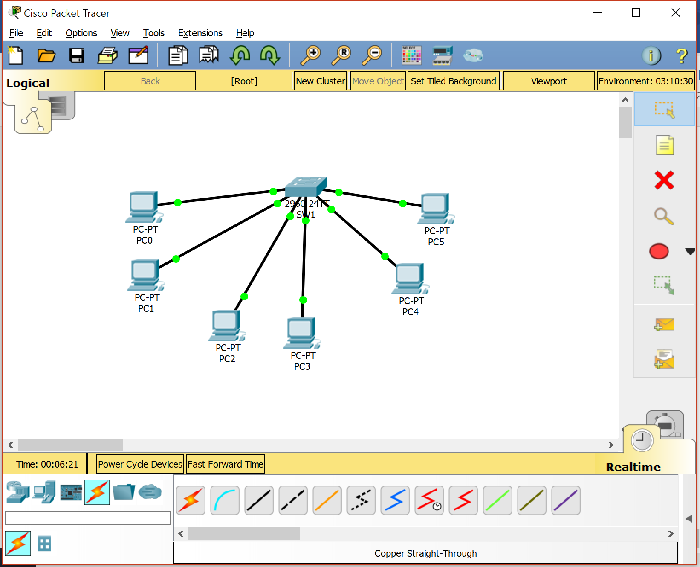

Step 3: Configure no ip domain-lookup on SW1

Under the configure terminal mode, enter “no ip domain-lookup” command

**What is the purpose for no ip domain-lookup command on switch?**

**Keeping this on may slow down the user as commands or erroneous URLs will still just to be justified to an address, this will cause a hang. If not using a DNS server, this setting should be turned off.**

Step 4: Configure the enable secret password as cisco on SW1

C:\Users\75LCUI\AppData\Local\Temp\1493406770(1).png

Step 5: Configure the console and vty password as westchester on SW1

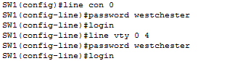

What is the meaning for line vty 0 4?

VTY or Virtual Teletype is essentially used for allowing connections from users via Telnet or SSH. So this command opens connection slots 0 through 4, allowing for 5 connections at any given time.

Step 6: Configure the exec-timeout command to the console and virtual terminal lines

C:\Users\75LCUI\AppData\Local\Temp\1493407102(1).png

**What is the purpose for command exec-timeout 0 0?**

Exec-timeout controls the amount of time the EXEC command interpreter waits for user input before timeout. The arguments it takes are minutes then seconds, 0 0 sets no timeout because it is 0 min 0 seconds.

**2.3 Creating VLANs and assign add interfaces to each VLAN**

Step 7: Create the VLANs as shown in figure 1

C:\Users\75LCUI\AppData\Local\Temp\1493407699(1).png

Configure vlan 20 (name SALES) and vlan 30 (name ENGINEERING) by using similar command.

**What is VLAN? Why we need VLAN?**

VLAN is a Virtual Local Area Network. It allows computers to be connected through a form of tunnel and appear as if they are all next to each other on the network. This can also be done to segregate computers within a LAN or group computers within a business that is spread across multiple cities through WAN. Only computers connected to the VLAN can see the other machines connected to the VLAN.

Step 8: verity vlan configuration by “do sh vlan” command

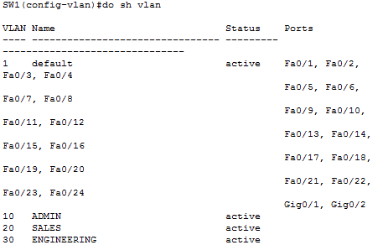

Step 9: Now, add interfaces to each of these VLANs with the switchport command as follows:

* interface Fa0/1, Fa0/2 belongs to VLAN 10, ADMIN
* interface Fa0/3, Fa0/4 belongs to VLAN 20, SALES
* interface Fa0/5, Fa0/6 belongs to VLAN 30, ENGINEERING

There are two ways to add interfaces: (1) add individual interfaces one by one, (2) add a range of interfaces. Let us start from the first method.

Step 9.1 add Fa0/1 and Fa0/2 to VLAN 10 individually

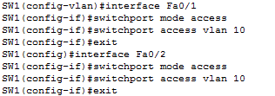

Step 9.2 add ports Fa0/3 – Fa0/4 to VLAN 20 as a group

C:\Users\75LCUI\AppData\Local\Temp\1493650837(1).png

Configure interface fa0/5 and interface fa0/6 by using similar command.

Step 10: Verify your VLAN configuration using relevant show commands in Cisco IOS.

Show vlan configuration by using command “do sh vlan” under enable mode.

**Show your VLAN configuration screenshot.**

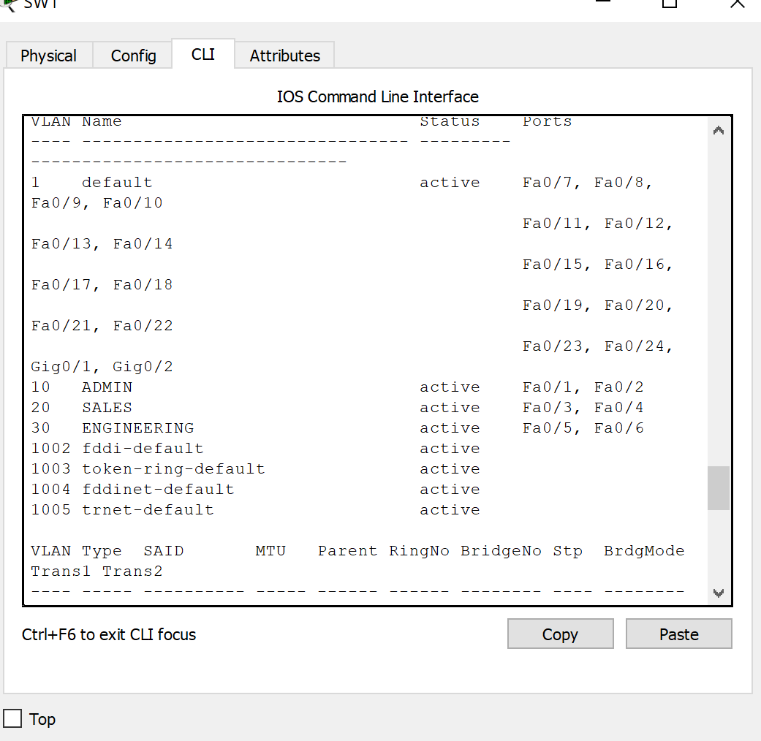

**2.4 Verify VLANs**

Step 11: assign IP address to hosts

You can click the PC, then select Desktop tab, choose IP configuration and enter the IP address

* PC0: 192.168.1.100 255.255.255.0
* PC1: 192.168.1.101 255.255.255.0
* PC2: 192.168.2.100 255.255.255.0
* PC3: 192.168.2.101 255.255.255.0
* PC4: 192.168.3.100 255.255.255.0
* PC5: 192.168.3.101 255.255.255.0

Step 12: ping within VLAN

For example, you can click PC0, select Desktop tab, choose command prompt, then ping PC1 by typing command “ping 192.168.1.101” (PC0 and PC1 are in the same VLAN). You can also ping PC3 from PC2 (vice versa), and ping PC5 from PC4 (vice versa) by using proper IP address.

**Can you successfully ping devices in the same VLAN? Show the screenshot from ping, and explain WHY.**

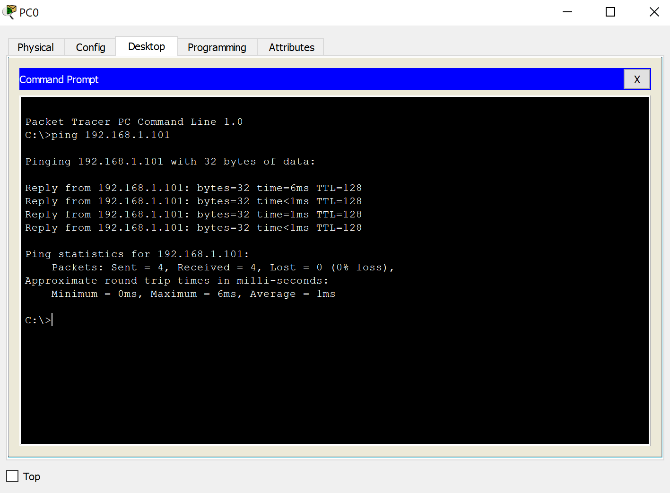

**Yes, since the computers are stuck into the same VLAN they can see each other. With PC0 and PC1 both being on the same VLAN, they have no issue communicating. But since PC2 is on a separate VLAN from PC0 they cannot communicate or see each other on the network. The VLAN is a virtual connection that is currently only servicing two ports each, so only two machines will be able to see each other.**

Step 13: ping devices in other VLAN

For example, you can click PC0, select Desktop tab, choose command prompt, then ping PC2, PC3, PC4, or PC5, such as “ping 192.168.1.105”

**Can you successfully ping devices in other VLANs? Show the screenshot from ping, and explain WHY.**

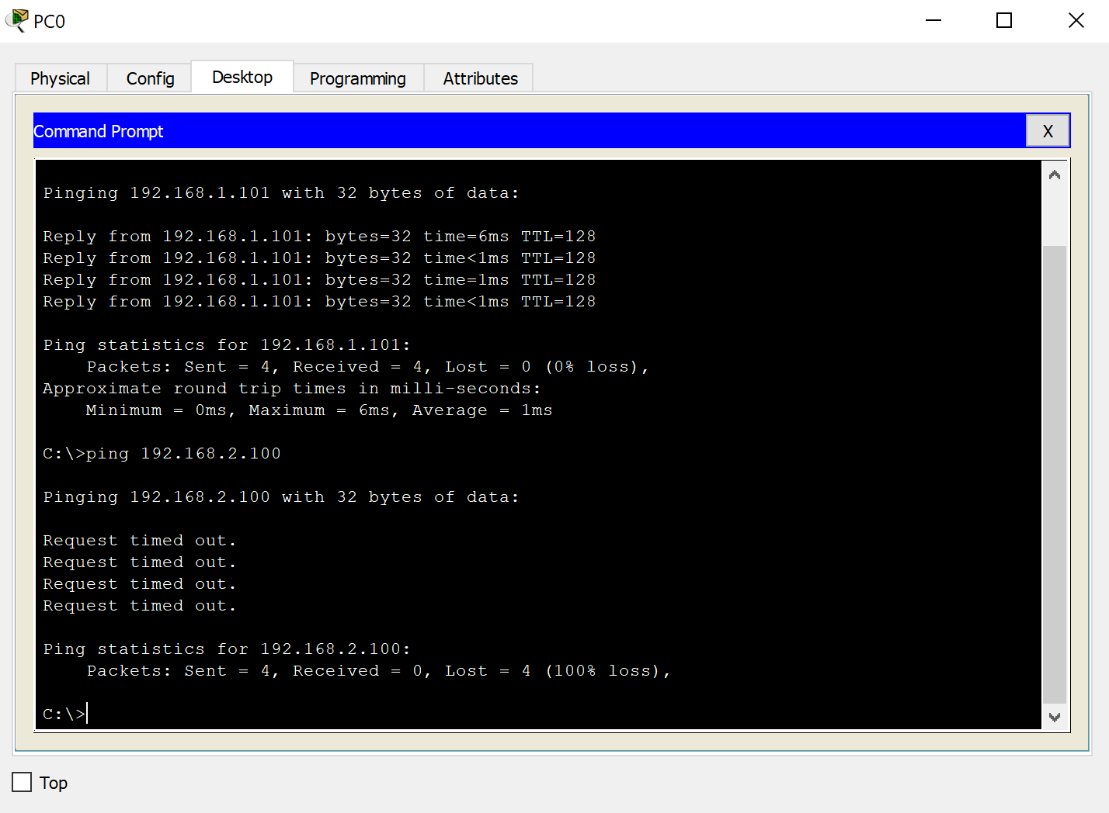

No, because the connections are segregated with a VLAN, even though there is a physical connection that we can trace, the other machine is on its own virtual network, and completely hidden from other machines not on that VLAN.

**2.5 OPTIONAL: Configure Inter VLAN Routing (10 points towards final grade)**

**Configure inter VLAN routing through Layer 3 switch. Show all the configuration steps as I did previously. Eventually, show that PC0 can successfully ping PC5.**



